Calendar Use Case

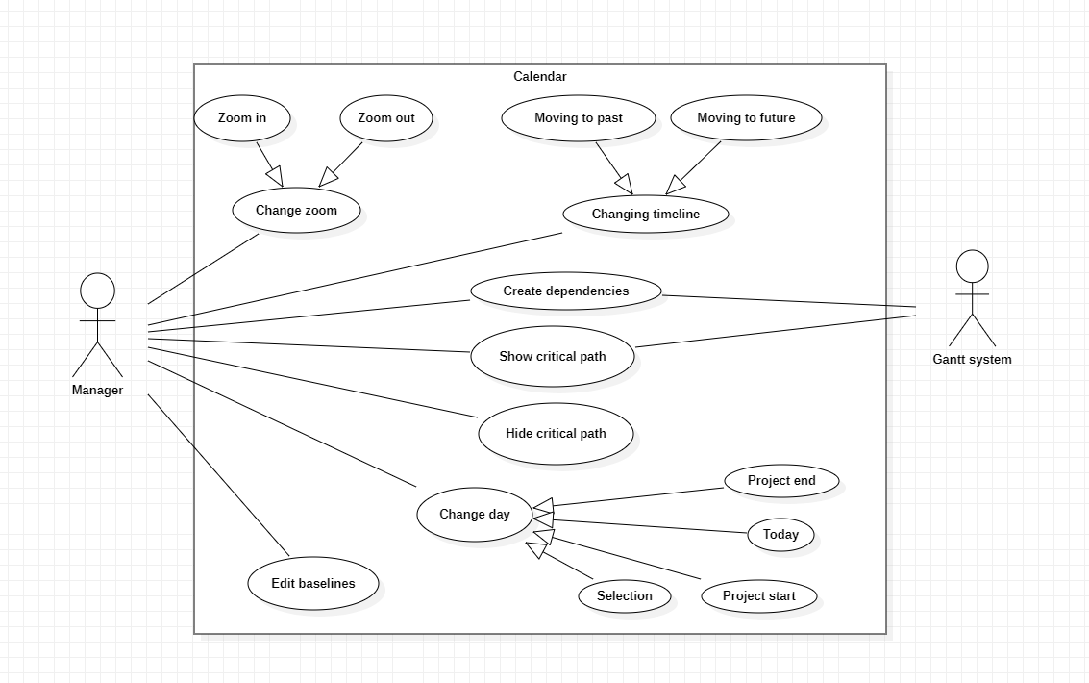

Edit baselines

Pre-condition: None

The use case starts when the button is clicked and gives the option to change the size and color of the baselines.

Primary Actor:

* Manager.

Secondary Actor:

* None.

Change day

The use case starts when the selected date is chosen so it will let the manager change the specific date the calendar is displaying.

Primary Actor:

* Manager.

Secondary Actor:

* None.

Project end

Pre-condition: None.

The use case starts when the manager chooses the project end and shows the calendar where the project has ended.

Primary Actor:

* Manager.

Secondary Actor:

* None.

Today

Pre-condition: None.

The use case starts when the manager chooses today and shows the calendar in the present day.

Primary Actor:

* Manager.

Secondary Actor:

* None.

Project Start

Pre-condition: None.

The use case starts when the manager chooses project start and shows the calendar where the project has started.

Primary Actor:

* Manager.

Secondary Actor:

* None.

Selection

Pre-condition: None.

The use case starts when the manager chooses selection and shows the calendar where the selected task is.

Primary Actor:

* Manager.

Secondary Actor:

* None.

Show critical path

Pre-condition: Critical path is not shown.

The use case starts when the manager chooses the button show critical path and shows the critical path of our tasks using the Gantt system.

Primary Actor:

* Manager.

Secondary Actor:

* Gantt system.

Hide critical path

Pre-condition: None

The use case starts when the manager chooses the button hide critical path and stops showing the critical path of our tasks

Primary Actor:

* Manager.

Secondary Actor:

* None.

Create dependencies

Pre-condition: There needs to be at least 2 tasks to make a dependency.

The use case starts when the manager selects a task and links it with another one by an arrow, so it becomes dependent of the first task that was selected.

Primary Actor:

* Manager.

Secondary Actor:

* Gantt System.

Change timeline

The use case starts when the manager uses one of the buttons that lets the calendar go more

to the future or the past.

Primary Actor:

* Manager.

Secondary Actor:

* None.

Moving to past

Pre-condition: None.

The use case starts when the manager uses the button move to past that lets the calendar go more to the past.

Primary Actor:

* Manager.

Secondary Actor:

* None.

Moving to future

Pre-condition: None.

The use case starts when the manager uses the button move to future that lets the calendar go more to the future.

Primary Actor:

* Manager.

Secondary Actor:

* None.

Change zoom

The use case starts when the manager uses the buttons to zoom in or zoom out so it makes the calendar be further away or closer.

Primary Actor:

* Manager.

Secondary Actor:

* None.

Zoom in

Pre-condition: None.

The use case starts when the manager uses the button zoom in and makes the calendar closer so u can see in more detail the days.

Primary Actor:

* Manager.

Secondary Actor:

* None.

Zoom out

Pre-condition: None.

The use case starts when the manager uses the button zoom out and makes the calendar further so u can see the full picture better.

Primary Actor:

* Manager.

Secondary Actor:

* None.